This Pretest is to be completed as preparation for the Unit Test and will be graded as a section of this test.
Collaboration with classmates is permitted, but copying work is considered cheating and will result in a zero.
The use of class notes is not permitted to complete this assignment.

I. Areas of Regions
Directions: Calculate the area of the region enclosed by $y=−x^{2}+6$, $y=x$, and $x=0$ in the first quadrant.

Integrate with respect to x

Setup integral(s):

Area of Region = __________

Sketch the graph of the region:
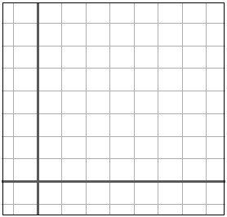
Integrate with respect to y

Setup integral(s):

Area of Region = __________

II. Disk Method III. Washer Method

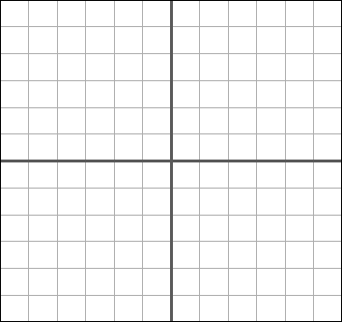

Circle one: dx dy

Limits: _____ to _____

Setup integral:

Volume = __________

$y=±\sqrt{x+1}$ $y=4$

Axis of Rotation: $y=−2$
$y=(x+1)^{2}$ $y=4$

Axis of Rotation:$y=−1$

Circle one: dx dy

Limits: _____ to _____

R = ________________

r = ________________

Setup integral:

Volume = __________

Circle one: dx dy

Limits: _____ to _____

r = ________________

h = ________________

Setup integral:

Volume = __________

Method: ____________

Circle one: dx dy

Limits: _____ to _____

R = ________________

r = _________________

h = ________________

Setup integral:

Volume = __________

V. Calculating Volumes
Apply any appropriate method to calculate the volume of the region. It may not be necessary to fill in all the blanks depending on the applied method.

IV. Shell Method

$$y=x^{3}−4$$

$x=2$ $y=−4$

Axis of Rotation:$x=−2$
$y=2x+1$ $x=0$ $y=3$

Axis of Rotation:$y=−2$

